**Brackley WI News**

**We would like to launch our new website at this address:** [**https://brackleywi.weebly.com**](https://brackleywi.weebly.com)

Our thanks go to Faye who has produced a great new website for us to all share. Why not take a look around the site and see how busy and clever Faye has been!

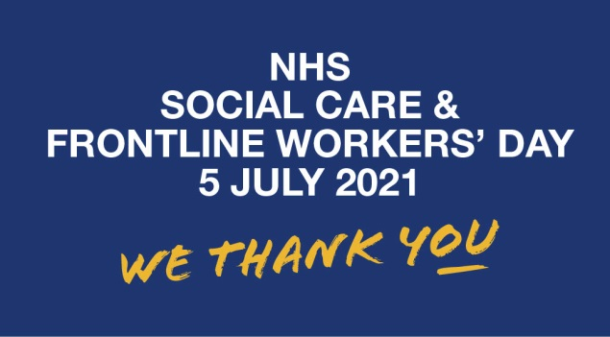

The first NHS, Social Care and Frontline Workers’ Day takes place on Monday, July 5th 2021. Brackley WI would like to celebrate this day and welcome our members to our first face to face meeting in over a year. We invite you to join us in **Brackley Park at 2:00 on 5th July** for Afternoon Tea and a good natter. (Just bring yourself and something to sit on.)

In order to keep everyone safe and comply with Government guidelines at the time of writing this newsletter we do need to know numbers. Please email me – [jgaskill55@yahoo.co.uk](mailto:jgaskill55@yahoo.co.uk) by 02/07/21 if you wish to attend.

On a less exciting note if it is raining on the day we will have to cancel but hopefully the sun will be shining and we can enjoy the afternoon with each other.

**Q:\140066.enu\MEDIA\CAGCAT10\j0088542.wmf**

**JUNE BIRTHDAYS:** Happy Birthday to everyone having a birthday this month – Elena, Margaret B, Anne G, Jan H, Eileen T and Barbara W



**BRACKLEY SCARECROW FESTIVAL**

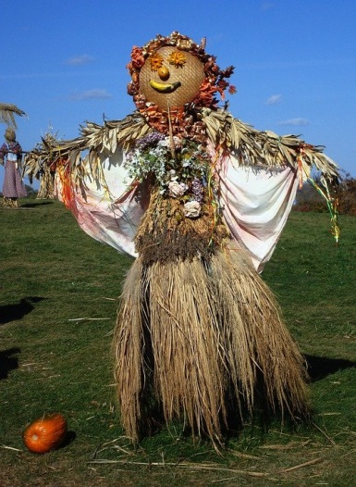

**Brackley Scarecrow Festival** is being held on 26 – 27 June. The theme is “The Great Outdoors” and our entry dressed as a Land Girl will be at Jenny’s house in Halse Road. A map will be created so you can plan your route around Brackley to see all the scarecrows.

**FUTURE MEETINGS:**

At the moment the committee is planning that from September we will be able to meet in the WI hall and we’ll keep you posted in our next newsletter.

Our next meetings are:

**Monday 14th June –** **Wine and Meat Bingo**.

At this meeting we will vote on the WI resolution “A call to increase awareness of the subtle signs of ovarian cancer”.

Followed by BINGO

**Monday 12th July –** **It Shouldn’t Happen to a Home Economist but it Generally Has... with Sian Fox**

Sian will take us through her varied career as a home economist. She’s worked with Jamie Oliver, the Calendar Girls and cooked in front of Royalty (well nearly).